Physics 131 Equations chapters 2-10

(See reverse for table of moment of inertia expressions)

Chapter 2: One-Dimensional Kinematics

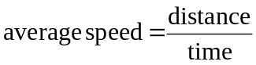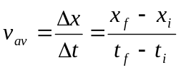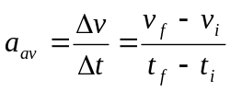

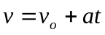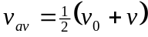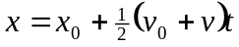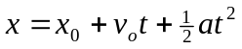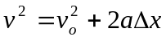

Chapter 3: Vectors in Physics

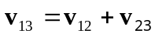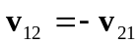

Chapter 4: Two-Dimensional Kinematics

basic equations of projectile motion:
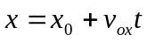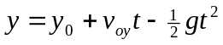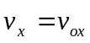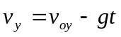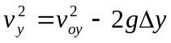

Chapter 5: Newton’s Laws of Motion

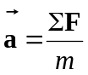
Chapter 6: Applications of Newton’s Laws

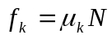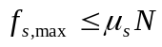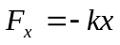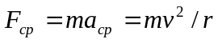

Chapter 7: Work and Kinetic Energy

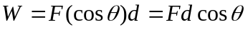
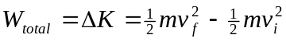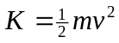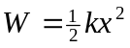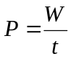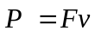

Chapter 8: Potential Energy and Conservation of Energy

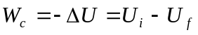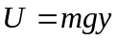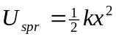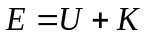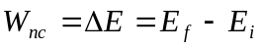

Chapter 9: Linear Momentum and Collisions
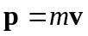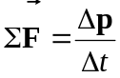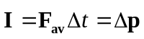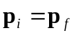

(continued on reverse)

Chapter 10: Rotational Kinematics and Energy

